

Design Document Version Draft

Call Data Record - Inter Operator Settlement

Document Control :

Project Revision History
Date | Version | Author | Brief Description of Changes |  |  |  | Approver Signature
12/08/2022 | Draft | Rajanala Durgadevi | Basic design and documentation

Team Members

Employee ID | Name
46240972 | Rajanala Durgadevi
46240998 | Hirijashree Rajendran
46238891 | K Rahul Sai
46240802 | Ibbani P

Table of Contents

- High Level Design

1.Introduction |  | 4
1.1 | Purpose | 4
1.2 | Scope | 4
1.3 | Definitions | 4
1.4 | Overview | 4
2.General Description |  | 5
2.1 | Product Perspective | 5
2.2 | Tools used | 5
2.3 | General Constraints | 5
2.4 | Assumptions | 5
2.5 | Special Design aspects | 5
3.Design Details |  | 5
3.1 | Main Design Features | 5
3.2 | Application Architecture | 5
3.3 | Application Block Diagram | 6
3.4 | Standards | 6
3.5 | Data Block Diagram | 7
3.6 | Files | 8
3.7 | Error Handling | 8
3.8 | Interfaces | 8
3.9 | Help | 8
3.10 | Performance | 8
3.11 | Security | 9
3.12 | Reliability | 9
3.13 | Maintainability | 9
3.14 | Portability | 9
3.15 | Reusability | 9
3.16 | Application compatibility | 9
3.17 | Resource utilization | 9
3.18 | Major Classes | 9
- Functional Requirements |  | 10
4.1 | Sign up, login and create client -server connection | 10
4.2 | Request to server from client | 10
4.3 | MSISDN | 10
4.4 | Brand name | 10
4.5 | MNC/MMC | 10
4.6 | MOC: Outgoing Voice Call | 10
4.7 | MTC: Incoming Voice Call | 10
4.8 | SMS-MO: Outgoing Message | 11
4.9 | SMS-MT: Incoming Message | 11
4.10 | Download: MB downloaded if call type is GPRS | 11
4.11 | Upload: MB uploaded if call type is GPRS | 11
4.12 | Third party MSISDN | 12
4.13 | Third party Subscriber MMC/MNC | 12
4.14 | Server-client process | 12

- Low Level Design

5. Introduction |  | 13
5.1 | Purpose | 13
5.2 | Document Conventions | 13
5.3 | Intended Audience and Reading Suggestions | 13
5.4 | References | 13
6. Detailed System Design |  | 13
6.1 | Design Descriptions | 14
6.2 | CDR Activity Diagram | 14
6.3 | CDR Flow Diagram | 15
6.4 | Class Diagram | 16
6.5 | Use Case Diagram | 17
6.6 | Design and Implementation Constraints | 17
6.7 | User Interfaces | 17
6.8 | Security | 17
- Appendix A: Glossary |  | 17

High Level Design

- Introduction

Every time a call is placed on a telecommunication network, descriptive information about the call is saved as a Call Data Record (CDR). Millions of CDR’s are generated and stored every day. In addition, at minimum, each Call Data Record has to include the originating and terminating phone numbers, the date and time of the call, and the duration of the call.
1.1 Purpose

The purpose of this High Level Design (HLD) Document is to add the necessary detail to the current project description to represent a suitable model for coding. This document is also intended to help detect contradictions prior to coding, and can be used as a reference manual for how the modules interact at a high level. The purpose of CDR - IOS is to produce total information of SMS send/receive, incoming/outgoing calls within mobile operator/outside mobile operator and total data downloaded/uploaded.

1.2 Scope

This document provides a comprehensive high level design overview of the Call Data Record. It highlights the high level flow / use cases in inter operator settlement and serves as an input to the low level design documents that would further elaborate on the proposed system design

1.3 Definitions

1.4 Overview

This HLD Document is arranged in the following format :
-Section1 : Introduction

A brief explanation about the purpose, scope and design format of the proposed system.

- Section2 : General Description

This section is all about the general constraints, assumptions and design aspect associated with the proposed system .The product perspective will gives an overall description of the system.

- Section3 : Design Details

This section documents the detailed design of all modules associated with the development of the proposed system.

- Section4 : Functional Requirements
This section contains the information about requirements of this project, what we have to implement.

- General Description

2.1 Product Perspective

The Call Data Record aim is to display the aggregate information of operators separately. The concepts used in this system are buffer to collect and to store the large CDR files (1-5 MB)from CDR generator, file reader to read the file from buffer, parser to parse the CDR file information, fork to display the total information of SMS, calls and data of within and outside operators. The system is basically constructed using C++ language .

2.2 Tools used

- Ubuntu operating system
- C++ language is used.
- Draw io is used for pictorial representations.

2.3 General Constraints

The Call Data Record is fixed. We cannot enhance further. Here we are not using any software, but we are getting generated CDR files.

2.4 Assumptions

CDR file is the dependency for the project. Without CDR file we can’t do the process of this project.

2.5 Special Design aspects

One of the design aspects is that we can display the call data information for both customer billing and inter operator settlement.

3 Design Details

3.1 Main Design Features

The main design features include four major parts: the architecture, the user interface design, the files, process relation. In order to make these designs easier to understand, the design has been illustrated in attached diagrams ( Use Case, Data flow diagrams).

3.2 Application Architecture

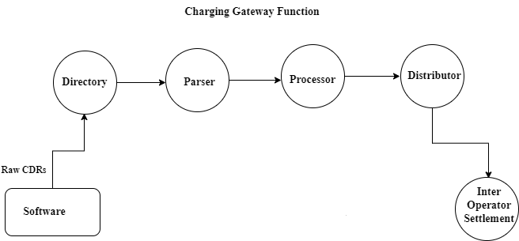

3.3 Application Block Diagram

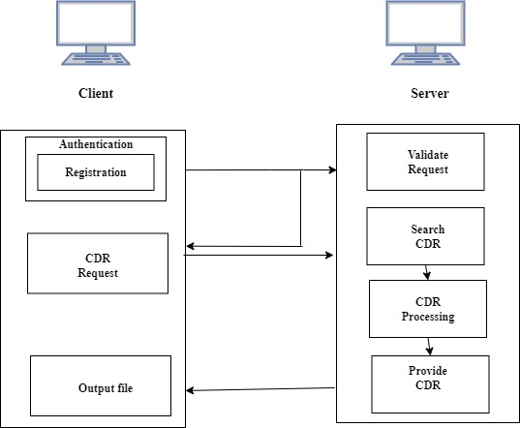

3.4 Standards

Security – The system shall be capable of receiving charging information in the form of CDR data and bulk meter data recorded in the switch and transferred on-line through the data network. Here we are getting CDR file, which contains pipe line as delimiter to separate each column of data. For other CDR files different delimiter may used.(: , ;).

Each line consists of information of MSISDN of first operator, MNC/MMC of first operator, call type, duration in seconds, download data in MB, upload data in MB, MSISDN of second operator, MNC/MMC of second operator.

Ex:1037928|Rami levi|42502|SMS-MT|0|0|0|1136404|42504
1800253|Partner|42501|GPRS|0|0|337||42504

It search call record based MSISDN which is given in first column. Here based on country code of operators we will get to know that, is the subscriber contacted same operator or not. If both the country codes are same(3rd and 9th columns), then process done between same operators. Otherwise, process done between different operators. We have 5 types of call types, namely SMS-MT (Incoming Message), SMS-MO (Outgoing message), MTC (Incoming call), MOC (Outgoing call), GPRS which are present in 4th column. If SMS-MT is present in 4th column, then remaining call types become zero. 5th column gives the information about duration of call in seconds between same /different operators. 6th column and 7th column gives information about downloaded and uploaded data in MB respectively. Here we don’t have particular information about SMS. So, when SMS-MT or SMS-MO present in 4th column, we consider it as “1” otherwise as “0”. 8th column contains MSISDN of second operator. Here we tokenization to parse the data and we use fork concept to display output for customer billing and inter operator settlement. In customer billing we will get all information which is given in CDR file separately for each operator by searching MSISDN. In inter operator settlement we will get all information which is given in CDR file combinely i.e. we will get total call, sms, network data information of both operators by searching country code.

Output: Operator Brand: Rama levi (42502)
Incoming voice call duration:0
Outgoing voice call duration:0
Incoming Messages:1
Outgoing Messages:0
MB downloaded: 0 | MB uploaded: 337

3.5 Data Block Diagram

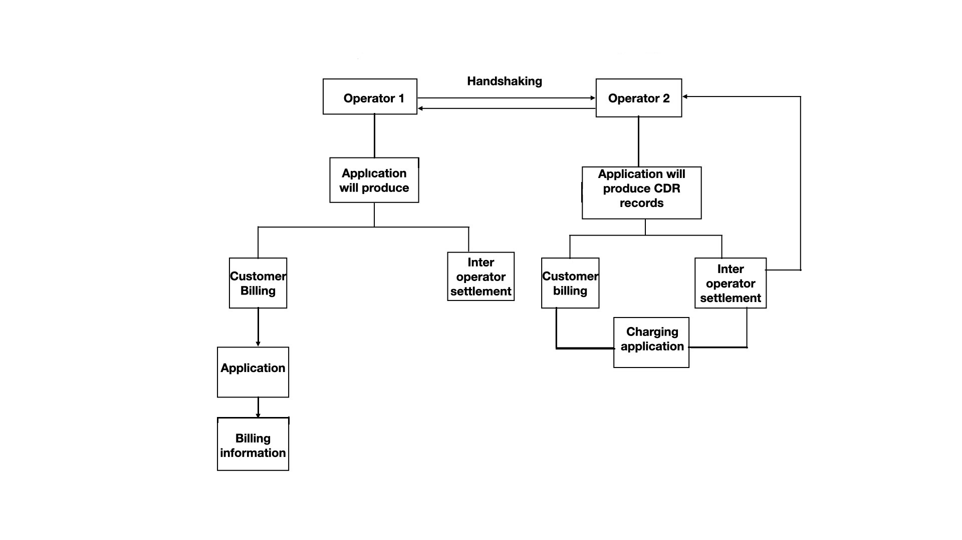

3.6 Files

The Call Data Record is files are the logs which contains information of incoming/ outgoing voice calls/SMS, data downloaded/uploaded. CDR files contains information of several clients.

3.7 Error Handling

Should errors be encountered, an explanation will be displayed as to what went wrong.
An error will be defined as anything that falls outside the normal and intended usage.

If CDR file is not present then display proper message in client. If CDR file contains improper data , then skip that information and display proper message in client side. If unable to login, then it will throw an error.

3.8 Interfaces

Not Applicable

3.9 Help

Help will come in the form of all the documentation created prior to coding, which explain the intended uses.

3.10 Performance
Performance is going to be very important for this project. For everything to run smoothly for this project, The system will work on the CDR file and the performance depends upon the software implementation of inter operator settlement.

3.11 Security

The system shall be capable of receiving charging information in the form of CDR data and here we are providing authentication, so only registered candidates can access CDR files.

3.12 Reliability

The system is available when the authenticated person get requested to produce inter-operator settlement information.

3.13 Maintainability

We have to maintain internet data records of subscribers for services provided such as internet access, e-mail, internet telephony services like calls made from mobile application or wifi for at least 2 years.
3.14 Portability

Code and program portability should be possible between kernel-recompiled Linux distributions. For everything to work properly, all components should be compiled from source.

3.15 Reusability

The code written should have the ability to be reused with no problems. Should time allow, and detailed instructions are written on how to create this project, everything will be completely reusable to anyone.

3.16 Application compatibility

The CDR file is compatible to produce the subscriber call information for any operator.

3.17 Resource utilization

The record is maintained by the concerned telephone exchange and contains call details such as duration of the call, source and destination MSISDN,MMC/MNC number, call type etc. Call detail records serve a valuable purpose of revenue generation for telephone service providers and are critical for law enforcement, whenever required.

3.18 Major Classes

There are a total of two classes: Operator, User.

- Functional Requirements

It gives the overview of functional requirements for this project

4.1 Sign up, login and create client -server connection

- Do sign up, login and create client-server connection using TCP technology

4.2 Request to server from client

- Client have to send a request to server to get CDR file which is stored in STL container and store the processed data in STL container.

4.3 MSISDN

- Unique number identifying a subscription in a mobile network maximum length of an MSISDN to 7 digits.

4.4 Brand Name

- Subscriber Brand Name: a string maximum 64 chars. Such as “Airtel”.

4.5 MMC/MNC

- Subscriber MMC/MNC: mobile country code and mobile network code maximum 6 digits.

4.6 MOC: Outgoing Voice Call

- Inter Operator Settlement contains information about “Outgoing voice calls duration to a subscriber within the mobile operator.”

Ex: Airtel is the Mobile operator for the person who called and who receives that call. We have to note the duration of that outgoing call

- Inter Operator Settlement contains information about “Outgoing voice calls duration to a subscriber outside the mobile operator.”

Ex: Airtel is the Mobile operator for the person who called and Idea is the Mobile operator who receives that call. We have to note the duration of that outgoing call.

4.7 MTC: Incoming Voice Call

- Inter Operator Settlement contains information about “Incoming voice calls duration to a subscriber within the mobile operator.”

Ex: Airtel is the Mobile operator for the person who called and who receives that call. We have to note the duration of that incoming call.

- Inter Operator Settlement contains information about “Outgoing voice calls duration to a subscriber outside the mobile operator.”

Ex: Airtel is the Mobile operator for the person who called and Idea is the Mobile operator who receives that call. We have to note the duration of that incoming call.

4.8 SMS-MO: Outgoing Message

- Inter Operator Settlement contains information about “SMS messages sent within the mobile operator.”

Ex: Subscriber with Airtel mobile operator sent message to the the subscriber of Airtel mobile operator itself. We have to know the source and destination phone numbers.

- Inter Operator Settlement contains information about “SMS messages sent outside the mobile operator.”

Ex: Subscriber with Airtel mobile operator sent message to the the subscriber of BSNL mobile operator. We have to know the source and destination phone numbers.

4.9 SMS-MT: Incoming Message

- Inter Operator Settlement contains information about “SMS messages received within the mobile operator.”

Ex: Subscriber with Airtel mobile operator receives message from the subscriber of Airtel mobile operator itself. We have to know the source and destination phone numbers.

- Inter Operator Settlement contains information about “SMS messages received outside the mobile operator.”

Ex: Subscriber with Airtel mobile operator receives message from the subscriber of BSNL mobile operator. We have to know the source and destination phone numbers.

4.10 Download: MB downloaded if call type is GPRS

- Inter Operator Settlement contains information about “MB downloaded.”

Ex: If you have downloaded anything from browser, or received any files from any other sources, then we have to note that how much data had been used to download those files

4.11 Upload: MB uploaded if call type is GPRS

- Inter Operator Settlement contains information about “MB uploaded.”

Ex: If you have uploaded anything to drive, or shared any files to any other sources like whats app or gmail, then we have to note that how much data had been used to upload those files.

4.12 Third party MSISDN

- Corresponding third party in this call, empty for GPRS

4.13 Third party Subscriber MMC/MNC

- Corresponding third party’s mobile subscriber in this call.

4.14 Server-client process

- If CDR file is not present then display proper message in client and if cdr file contains improper data skip that info and display proper message in client side

- Get total call duration, SMS within and outside for all clients and total download /upload data

- After the client exits from the server, the generated output should be moved to the file.

- Search for particular client (subscriber) using client id(country code) to get the complete result on to the screen

- Using the data in STL container get the result only for that id (country cod), if present else display proper message.

- Search for a particular client id(country code) for particular set of information i.e get total SMS sent/received, incoming/outgoing calls within mobile operator/outside mobile operator and total data download/upload. Then disconnect with server.

Low Level Design

- Introduction

The aim of this document is to gather, analyze and give an in-depth insight into the complete Call data Record Inter Operator Settlement by defining the problem statement in detail. The intended audience includes all stakeholders in the potential system. This include subscribers of each operator. The detailed low level design of the Call data Record Inter Operator Settlement are provided in this document.

  - Purpose

Purpose of this project is to provide A call detail record (CDR) is a data record produced by a telephone exchange or other telecommunications equipment that documents the details of a telephone call or other telecommunications transactions (e.g., text message) that passes through that facility or device. The record contains various attributes of the call, such as time, duration, completion status, source number, and destination number.

Document Conventions

Title of the project is mentioned with “Times New Roman” as font and “28” as font size. For main headings font given as “Times New Roman” as font and “16” as font. For subheadings font given as “Times New Roman” as font and “14” as font and for further subheadings font given as “Times New Roman” as font and “12” as font.

Intended Audience and Reading Suggestions

Document is primarily intended for members of Call Data Record Inter Operator Settlement team and Mentors which consists of trainees under Capgemini Training Program.

References

- https://docstore.mik.ua/univercd/cc/td/doc/product/wanbu/das/das_1_4/das14/das14apd.htm
- https://www.gl.com/Presentations/Call-Data-Records-Presentation.pdf
- https://en.wikipedia.org/wiki/Call_detail_record

Detailed System Design

The system design is as follows –

6.1 Design Descriptions

Every time a call is placed on a telecommunication network, descriptive information about the call is saved as a Call Data Record (CDR). Millions of CDR’s are generated and stored every day. In addition, at minimum, each Call Data Record has to include the originating and terminating phone numbers, the date and time of the call, and the duration of the call. The CDR’s might also include other kinds of data that are not necessary but are useful for Inter operator settlement, for instance, the identifier of the telephone exchange writing the record, a sequence number identifying the record, the result of the call (whether it was answered, busy, etc.), the route by which the call entered the exchange, any fault condition encountered, and any features used during the call, such as call waiting.

Call Data Record file have to collect from any software. We have to store those CDR files in buffer. To access those file we have to provide authentication for securing those files. Authorized users have to parse the data of MSISDN, MNC/MMC, call type means incoming call/outgoing calls of same/different operator, incoming messages/outgoing messages of same/different operator, data downloaded/uploaded in MB and call duration of same /different operators.

6.2 CDR Activity Diagram

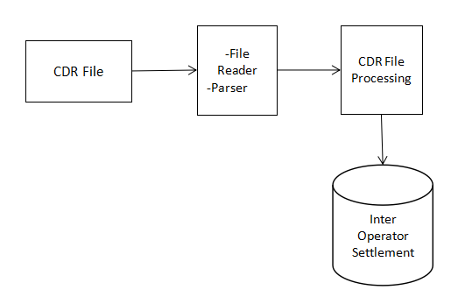

6.3 Data Flow Diagram

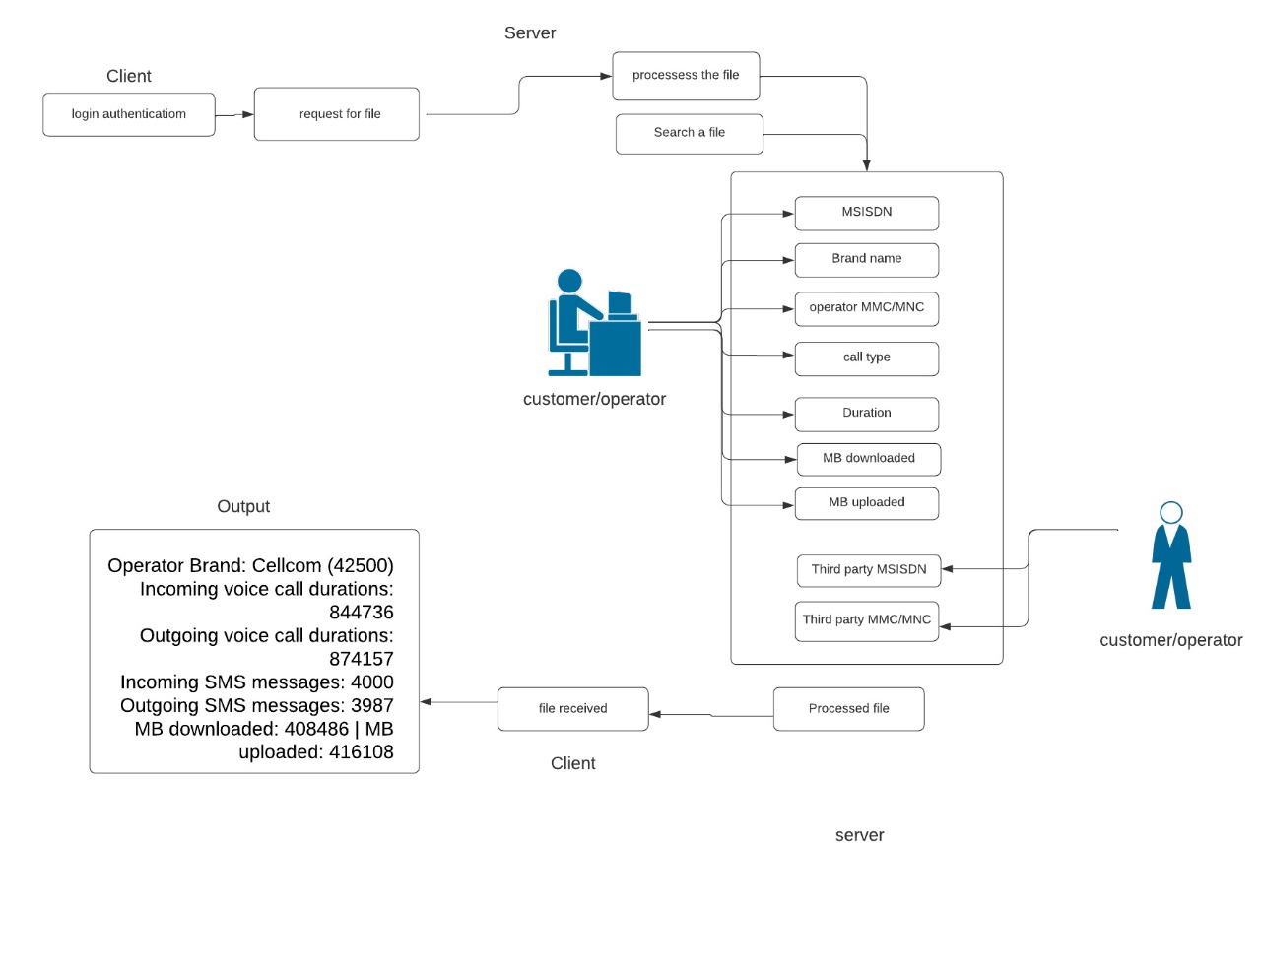

6.4 Class Diagram

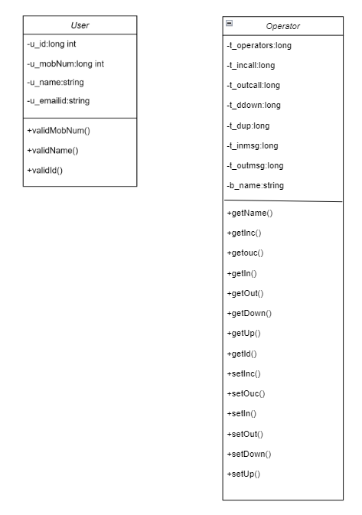

6.5 Use Case Diagram

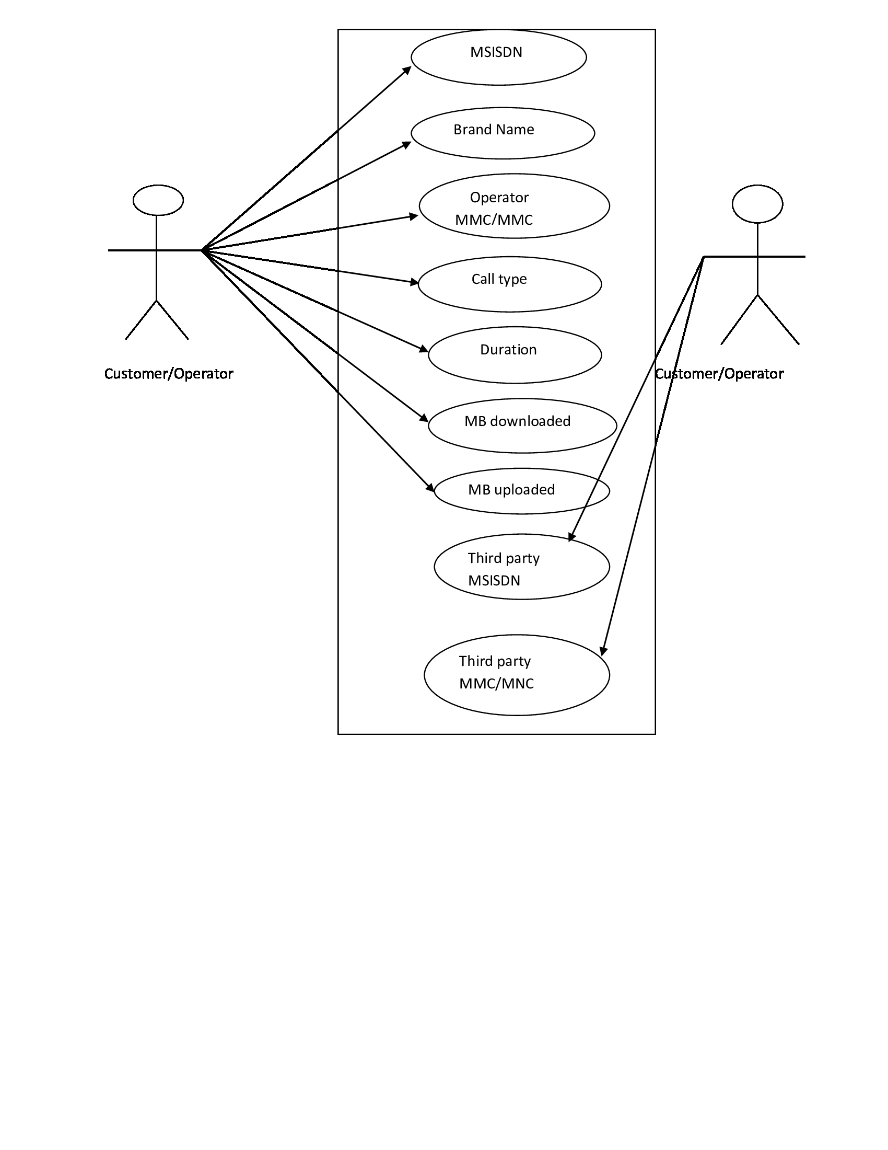
6.6 Design and Implementation Constraints

The system is built using C++ language.

6.7 User Interfaces

We have used the file processing to read CDR file, parsing the data using tokenization, fork
to do process of inter-operator settlement and STL map to store the CDR file data as database.

6.8 Security

The Call Data Record itself does not provide authentication and security. We are providing authentication to registered users only. We have to store the data in STL map.

- Appendix A: Glossary
CDR | Call Data Record
ISDN | Integrated Services Digital Network
MSISDN | Mobile Subscriber – ISDN Number
MOC | Mobile Originated Call
MTC | Mobile Terminated Call
SMS-MO | Short Message Service- Mobile Originated
SMS-MT | Short Message Service- Mobile Terminated
GPRS | General Packet Radio Services
MCC | Mobile Country Code
MNC | Mobile Network code
SDR | Subscriber Detail Record
SIM | Subscriber Identity Module
BTS | Base Transceiver Station
IMEI | International Mobile Equipment Identity
TAC | Type Allocation Code
IMSI | International Mobile Subscriber Identity
CDMA | Code Division Multiple Access
GSM | Global Positioning System
LTE | Long Term Evolution
UMTS | Universal Mobile Telecommunications Service

